**Task 1 — Website plan**

1. Briefly describe the purpose of the website.
2. Identify the target audience of this website.
3. Identify three requirements for this website.
4. List the hardware devices required to create this website.
5. List the software required to create this website.

(a) The purpose of the website is to encourage students in the Huckleberry High School to consider pursuing a career in Computing by providing information on the benefits and opportunities of working in the Computing industry, with a particular focus on development roles.

(b) The target audience of the website is students aged 11-18 in Huckleberry High School.

(c) Three requirements for this website are:

1. to be visually appealing and inclusive to all students,
2. to provide information on the benefits and opportunities of working in Computing, with a focus on development roles, and
3. to prominently display salary information.

(d) The hardware devices required to create this website include a computer/laptop and a reliable internet connection.

(e) The software required to create this website may include a web development platform or content management system (CMS) such as WordPress or Wix, a text editor for coding such as Sublime Text or Visual Studio Code, image editing software such as Adobe Photoshop or GIMP, and a web browser such as Chrome or Firefox for testing and viewing the website.

**Task 2 — Website design**

In the space below, sketch the overall structure of the website. (Navigation Structure)

1. Complete a wireframe to indicate the layout of **each page** in the website.

The wireframe should outline:

* + the content of each page (you do not need to write out text content in full)
  + the title of each page
  + the planned position of the text and images
  + internal and external links

You may annotate your wireframe or use the notes area to provide additional details about layout of the page or the page contents.

|  |
| --- |
| Page title: |
|  |
| Notes: |
|  |

Home Page

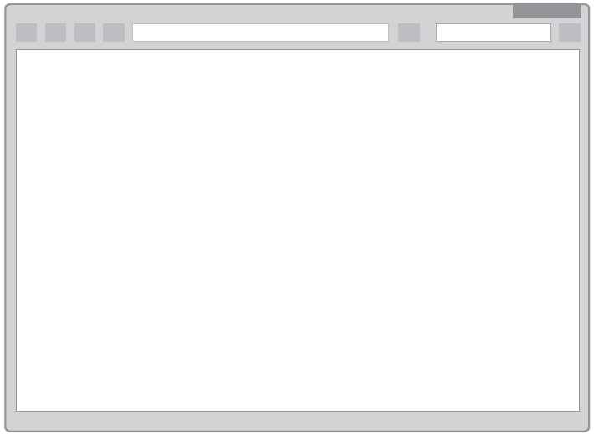

Page 2



Page 1

|  |  |
| --- | --- |
| Page title: | Page title: |
| Notes: | Notes: |

Page 2



Page 1

|  |  |
| --- | --- |
| Page title: | Page title: |
| Notes: | Notes: |

List all the media assets needed to construct this website.

|  |  |  |  |
| --- | --- | --- | --- |
| **Text** | **Graphics** | **Audio** | **Video** |
|  |  |  |  |